**CS587**

**Midterm Exam**

**St. Name: KARTHIKEYAN RAJALAKSHMI, VIGNESH KUMAR**

**St. ID: A20424508**

**10 points for every question**

**Q1**. For software project planning, quality shall be addressed at the software product level and software development process, Explain.

**Answer:**

For Software project planning, quality needs to be addressed at the Software product level and software development process.

The importance of addressing quality of Software Product:

* Software quality control (SQC) is about the quality of software product. By controlling the software quality,
* We can deliver good, non-defect software products to customers.
* We can identify bugs and defects before delivering to the customers.
* We can maintain external qualities as well as the internal quality of the system.
* Software quality assurance (SQA) is about the improving the process that governs the delivery and development of the software product.
* It makes sure the software meets the required quality.
* It helps in providing a more effective quality control mechanism.
* Assures that SW project participants follow the appropriate process.
* Incorporates Audit development groups to make sure that the process is done as per the ISO Standards.

**Q2**. If there is a task that needs more resources (engineers/labor hours) to be finished by the late-finish date, which one would be better: smoothing or assigning substitute resources in order to complete the task by the late finish date?

**Answer:**

On the question of resource smoothing or substitute resources (resource leveling), the preference would be of smoothing. Since smoothing does not affect the project schedule, it does not change the critical path. It make use of the slack time present in the project to complete the project in time. It is also cost effective compared to assigning resources.

Assigning substitute resources might lead to overhead in the project and also it might exceed the budget allocated for the particular project. Since resource smoothing does not affect the project schedule, budget, avoids over allocation of resources and it is also an efficient usage of resources' time, smoothing is considered better than assigning substitute resource. One more point to be noted is that substituting resource may need that resource to be trained based on the project which might cause increase in duration of the project.

**Q3**. Which one is better a network diagram with few Zero-Slack activities or many Zero-Slack activities?

**Answer:**

If an activity has a slack, whose value is greater than zero, then it means that this activity has more time to start and finish the project before the completion date.

If the activity has zero slack time then it denotes that there is no extra time. Which means each task present in the activity must be started at the earliest start date. Otherwise the project duration will extend and it causes delay in project delivery. This can also mean that critical path has zero slack.

In other words, if the project has many slack time then the critical path will be longer and the earliest finish date will be extended. So it gives out the conclusion that it is better to have many zero slack activities than having a few.

**Q4**. Explain when historical data of previous projects would be of limited use for estimating resource/effort requirements for new projects.

**Answer:**

Historical data would be of limited use in effort/resource requirement for new projects in the following cases:

* If the project is using the new technology or any advance instruments which has never been used in previous projects then the data from older projects will of be no use to estimate the resources/efforts for the current project.
* The teams and their skills also decide the effort required for the project. If the team members are more skilled in different domain then the amount required for different tasks might reduce which might also reduce the effort. In this case also the historical data won’t be of that much use.

**Q5**. Who controls the requirements review meeting? What are the different metrics collected in the requirements review meeting?

**Answer:**

The moderator controls thee review meeting for the requirements. Some tasks of the moderator are

1. Recording time for each activities.

2. Having the authority to fix reworks.

3. Can arrange re-review meeting to reduce the number of bugs.

4. Ensuring the data present for the review are with complete integrity and reviewed.

Metrics that can be collected during requirement review are:

**Do ability**: the changes obtained after the review can be done.

**Testability**: test cases for the new changes after the review.

**Correctness**: the validity of the requirements is checked.

**Conformance to standards**: the requirement changes and discussed are upto the standard of the organization.

**Ambiguity**: making sure the meaning is not interpreted differently for each person.

**Q6**. From the perspective of software product quality, software testing is only one aspect to ensure the quality of the software produced, Explain.

**Answer:**

Software Project Management has multiple phases and Software testing is one among the phases to test the product against the requirements. Software testing helps in finding bugs and fixing them. So that, it makes sure that product meets the quality required.

Testing examines the software to find the defects in the product.

Different types of testing include Unit testing, black box testing, white box testing.

Each test cases are kind of their own. Test results can be reviewed by all the team members and they can take steps to improve the software product.

Therefore, at the end of this phase, all the defects will be rectified fixed and the software product will be complete.  So testing is one aspect, where we will focus on the quality and scalability of the software product.

**Q7**. If a task is partition able, is this a sufficient condition to reduce the project duration? Explain.

If the task can be partitioned into smaller ones it is not necessary that it might reduce the duration of the entire project. The split tasks might need to be assigned different resources based on the requirement of the tasks. This might lead to unavailability of resource at that point of time and it has to wait until the resource gets released from some other tasks. Since the task has to wait for a certain amount of time to get started it will even lead to extension of project duration rather than reducing it.

The other case is that the split tasks can be of different complexities which can lead to each person taking different time to complete the task and then at last they have to be assembled together. So the partition able task is not sufficient enough condition to reduce the project duration.

**Q8**. What are the possible actions that the project manager and code inspection moderator might consider to take for the following outcomes of code inspection task?

1. Rework and bug fixes turned out to require more than 66% of the original effort to write the code.

The project manager and the code inspect moderator will decide to change the resources by sending the original resources back for training and assigning new resources to the project who they might consider to be efficient or suitable. Because when the task requires more than 50% of effort when compared to the original then it might cause the stretching of time duration required for fixing bugs and rework. So it’s better to assign new resources than risking project schedule and the quality.

1. Rework and bug fixes turned out to require roughly 19% of the original effort to write the code.

The project manager and the code inspect moderator might decide to conduct a re-review meeting and then try to take steps necessary reduce the bug fixes.

1. Rework and bug fixes turned out to require less than 3% of the original effort to write the code.

. The project manager and the code inspect moderator has to review and document the task but they don’t need to take any steps to reduce the bug fixes as 3% is considered as less than the threshold level.

**Q9**. Consider the following milestone table, what is the milestone trend chart that the following project follows?

|  |  |  |
| --- | --- | --- |
| **Milestone** | **Expected Delivery** | **Actual delivery** |
| Project Planning | 1st month | on-time |
| Requirement Phase | 2nd month | late 1 week |
| Analysis phase | 3rd month | early 1 week |
| Design phase | 4th month | early 1 week |
| Coding | 5th month | early 2 weeks |
| Unit Testing | 6th month | early 2 weeks |
| Integration Testing | 7th month | early 3 weeks |
| Documentation | 8th month | early 2 weeks |
| Installation/Training | 9th month | early 3 weeks |

**TREND CHART :**

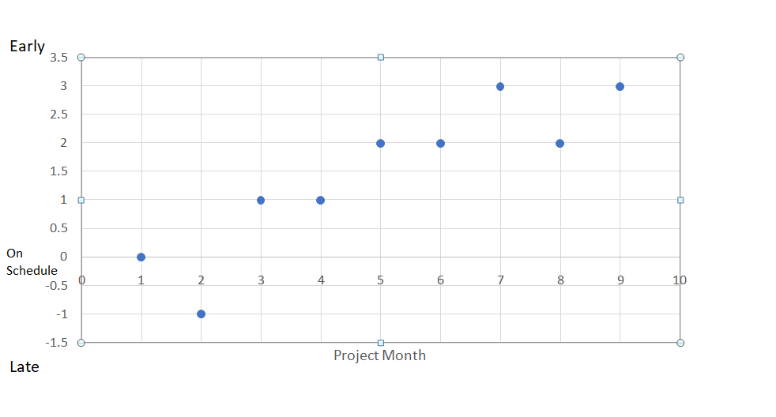**Q10**. Consider the following data; calculate the effort and duration required for every task, considering the following constraints:

1. An artifact is produced by only one author
2. Every review “meeting” task shall be carried by 5 engineers including the author
3. Every review “preparation” task shall be carried by 4 engineers excluding the author
4. Any “Rework” task can be executed by the author of the original task

|  |  |  |  |  |
| --- | --- | --- | --- | --- |
| **Tasks** | **Amount of Work** | **Productivity** | **Effort**  **(HOURS)** | **Duration**  **(DAYS)** |
| Requirements |  |  | 270 | 28 |
| Write Requirements Document | 200 pages | 1 page/Hour | 200 | 25 |
| Review Requirements Document |  |  | 60 | 1.75 |
| Review Preparation for Req. Doc. |  | 5 pages/Hour | 40 | 1.25 |
| Review Meeting |  | 10 pages/Hour | 20 | 0.5 |
| Rework | 10 defects | 1 defect/Hour | 10 | 1.25 |
|  |  |  |  |  |
| Design |  |  | 109.5 | 11.82 |
| Write Design Document | 65 pages | 1 page/Hour | 65 | 8.125 |
| Review Design Document |  |  | 19.5 | 0.57 |
| Preparation for Design Document |  | 5 pages/Hour | 13 | 0.41 |
| Review Meeting |  | 10 pages/Hour | 6.5 | 0.16 |
| Rework | 25 defects | 1 defect/Hour | 25 | 3.125 |
|  |  |  |  |  |
| Testing |  |  | 125 | 11.33 |
| Write Test Plan | 150 pages | 2 pages/Hour | 75 | 9.38 |
| Review Test Plan |  |  | 45 | 1.32 |
| Preparation for Test Plan |  | 5 pages/Hour | 30 | 0.94 |
| Review Meeting |  | 10 pages/Hour | 15 | 0.38 |
| Rework | 25 defects | 5 defects/Hour | 5 | 0.63 |